**Summer 2023: CS5710**

**Machin Learning**

**In-Class Programming Assignment-1**

Name: Sanath Kumar Ankala

ID: 700744158

GitHub : <https://github.com/SanathKumar22/Assignment1>

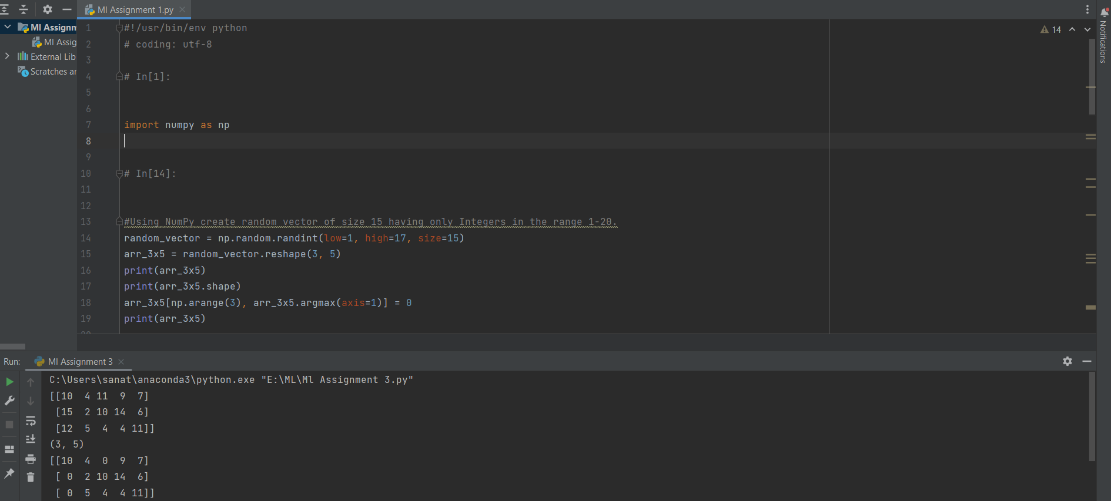

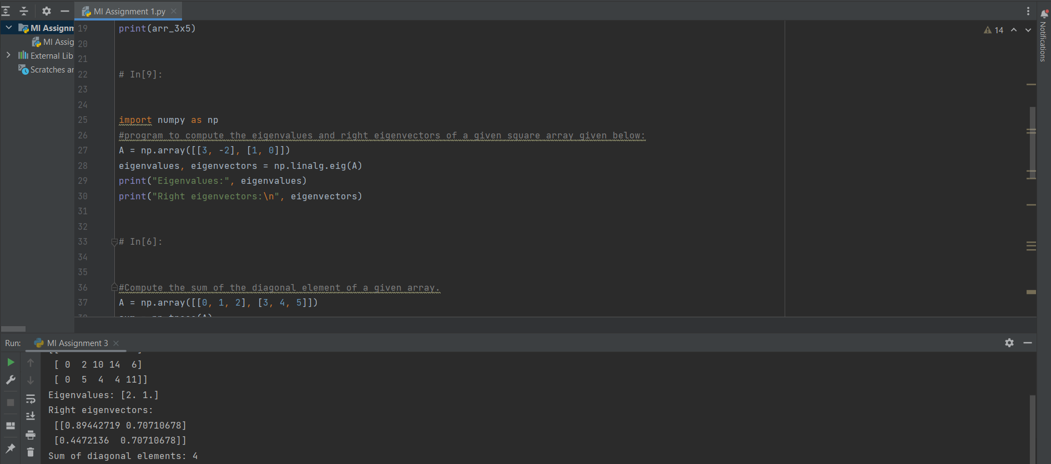

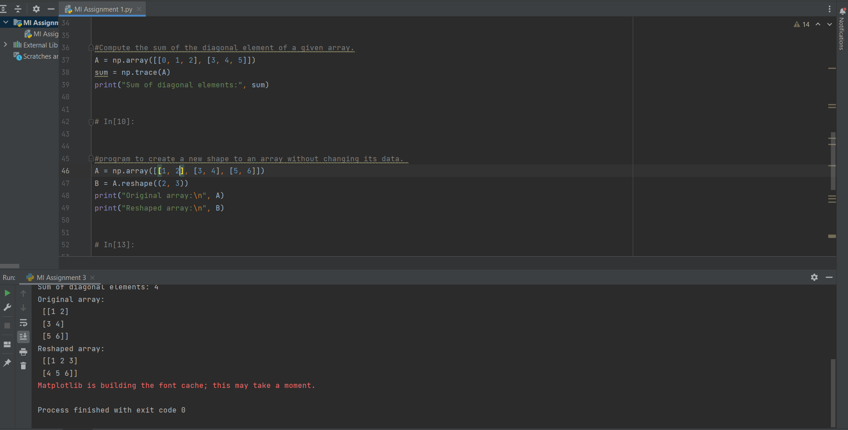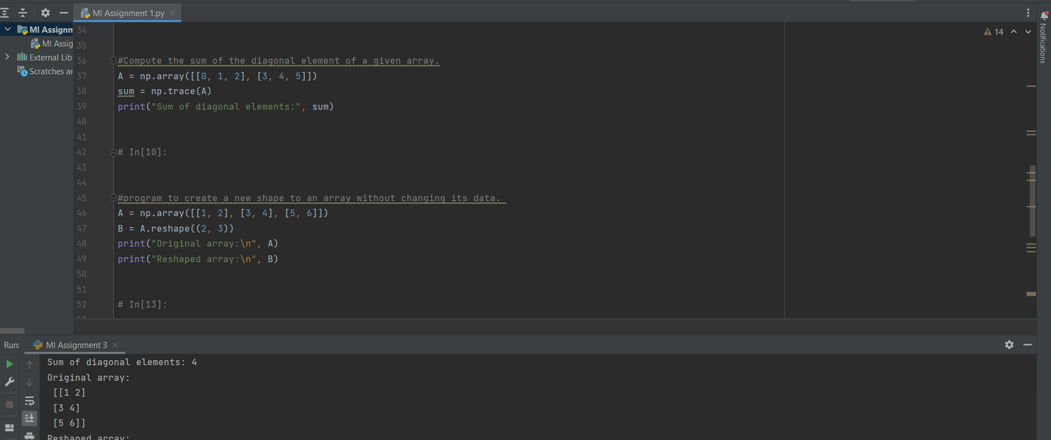

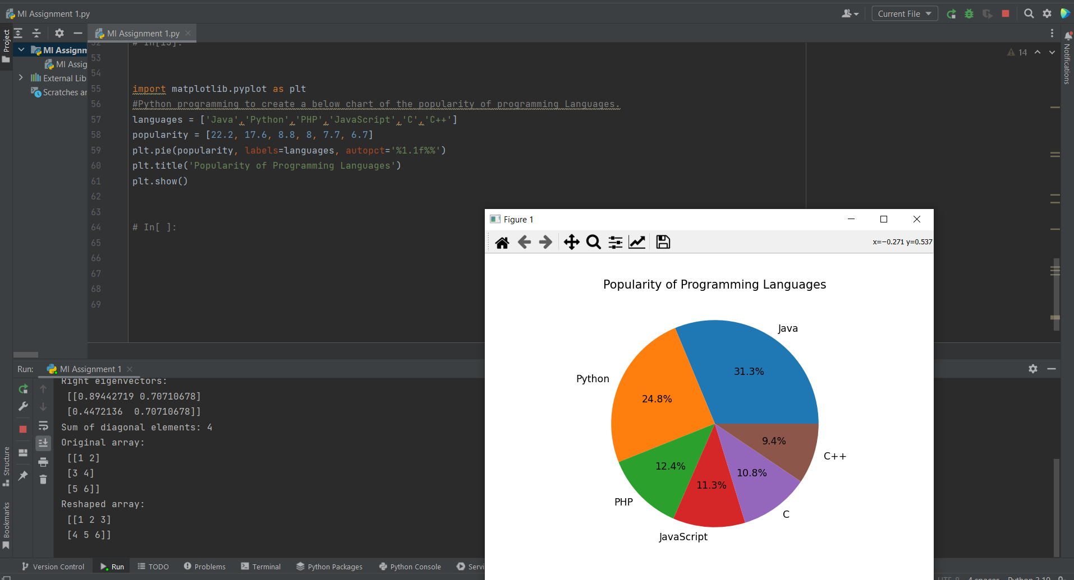

CODE:

#!/usr/bin/env python

# coding: utf-8

# In[1]:

import numpy as np

# In[14]:

#Using NumPy create random vector of size 15 having only Integers in the range 1-20.

random_vector = np.random.randint(low=1, high=17, size=15)

arr_3x5 = random_vector.reshape(3, 5)

print(arr_3x5)

print(arr_3x5.shape)

arr_3x5[np.arange(3), arr_3x5.argmax(axis=1)] = 0

print(arr_3x5)

# In[9]:

import numpy as np

#program to compute the eigenvalues and right eigenvectors of a given square array given below:

A = np.array([[3, -2], [1, 0]])

eigenvalues, eigenvectors = np.linalg.eig(A)

print("Eigenvalues:", eigenvalues)

print("Right eigenvectors:\n", eigenvectors)

# In[6]:

#Compute the sum of the diagonal element of a given array.

A = np.array([[0, 1, 2], [3, 4, 5]])

sum = np.trace(A)

print("Sum of diagonal elements:", sum)

# In[10]:

#program to create a new shape to an array without changing its data.

A = np.array([[1, 2], [3, 4], [5, 6]])

B = A.reshape((2, 3))

print("Original array:\n", A)

print("Reshaped array:\n", B)

# In[13]:

import matplotlib.pyplot as plt

#Python programming to create a below chart of the popularity of programming Languages.

languages = ['Java','Python','PHP','JavaScript','C','C++']

popularity = [22.2, 17.6, 8.8, 8, 7.7, 6.7]

plt.pie(popularity, labels=languages, autopct='%1.1f%%')

plt.title('Popularity of Programming Languages')

plt.show()

# In[ ]: